EC2 : Adding Volumes & Creating a Text File
Amazon EC2 (Elastic Compute Cloud) is a service provided by Amazon Web Services that allows users to run virtual machines (instances) in the cloud. These instances can be extended with additional storage using volumes.
Objectives:-
- Add a new storage volume to an EC2 instance
- Attach and mount the volume
- Create and store a text file in the volume
Step 1 : Launching an Instance
Log into AWS Management Console. Navigate to Amazon EC2. Click on Launch Instance. This starts the process of creating a virtual server in the cloud (a.k.a : instance).
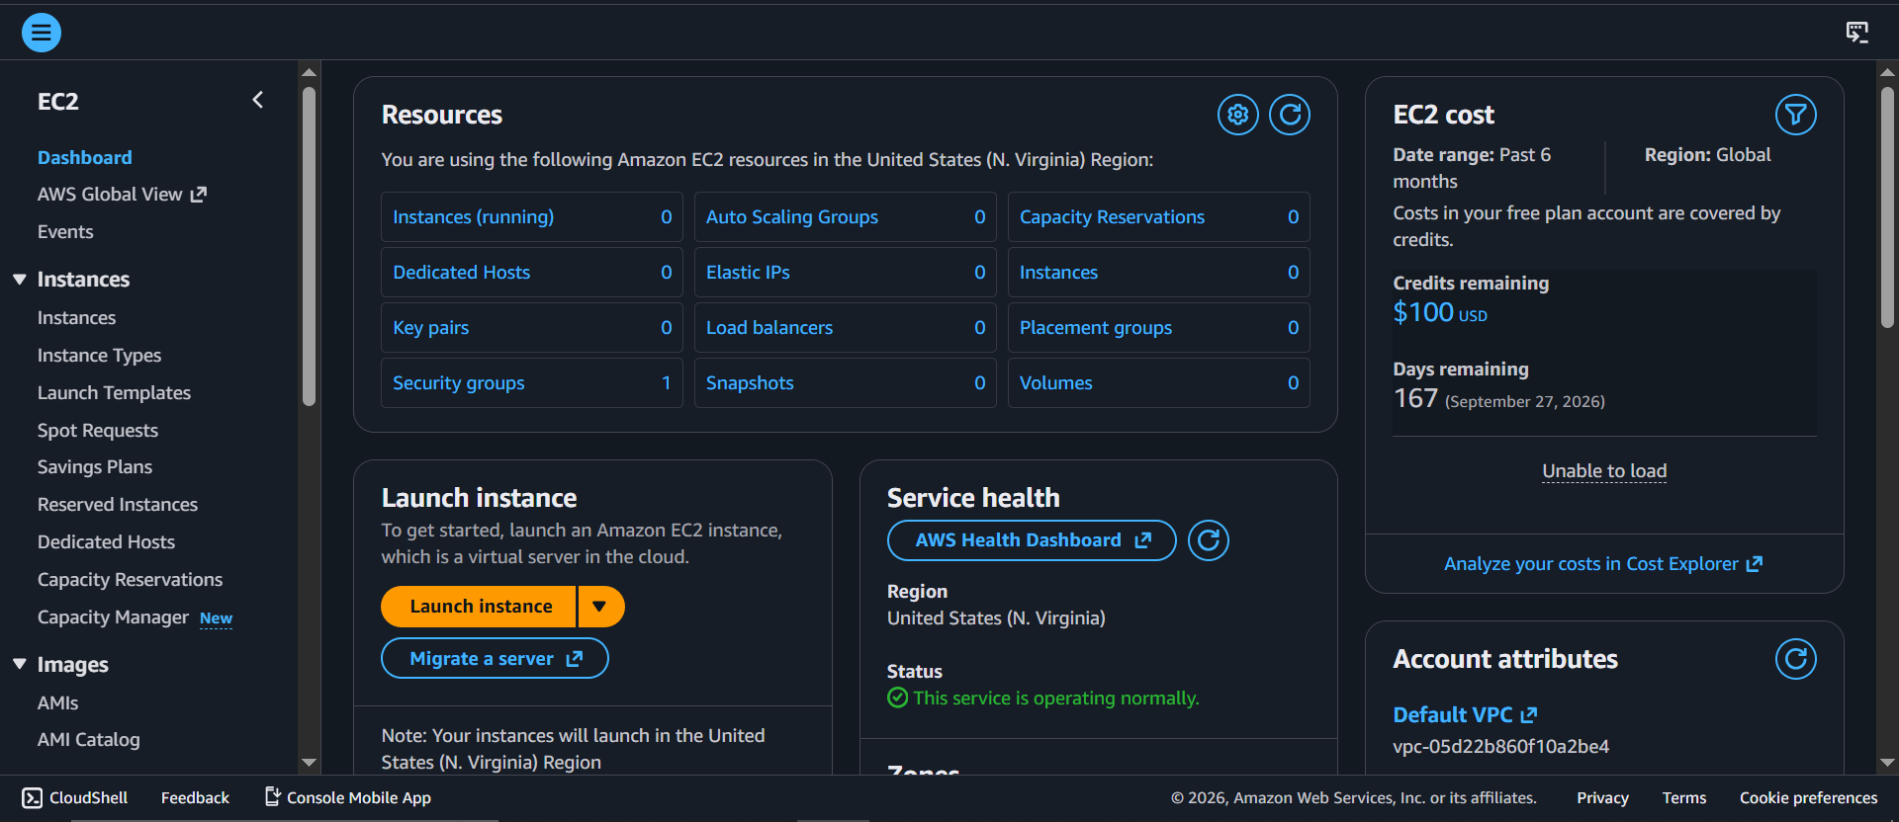
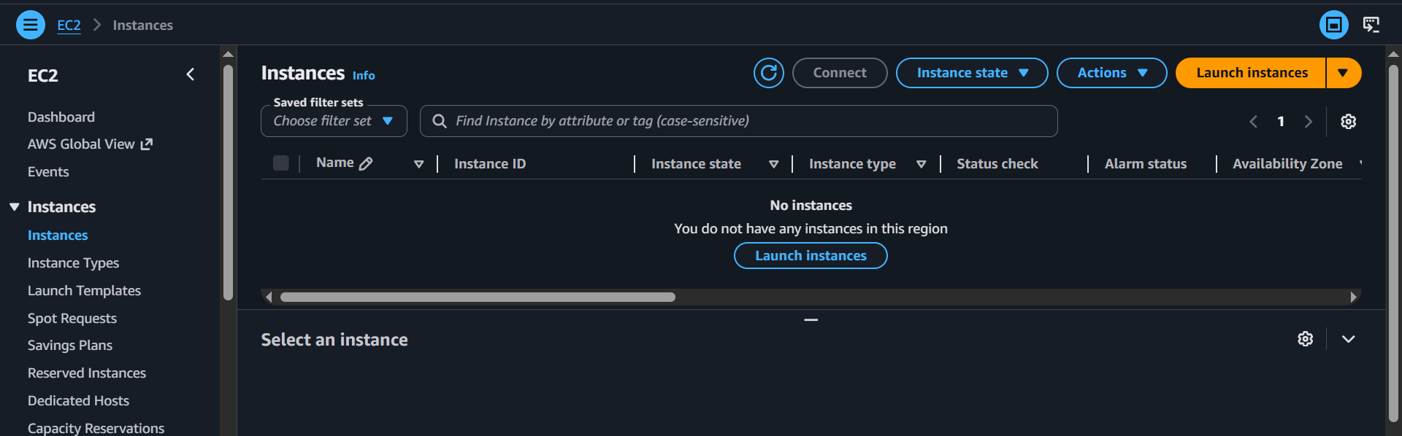
Step 2 : Launching an Instance
Here you can provide a name for your instance(e.g., Haadiyas Instances) and choose an Amazon Machine Image (AMI), which defines the operating system (e.g., Amazon Linux) and pre-installed software for the virtual server.
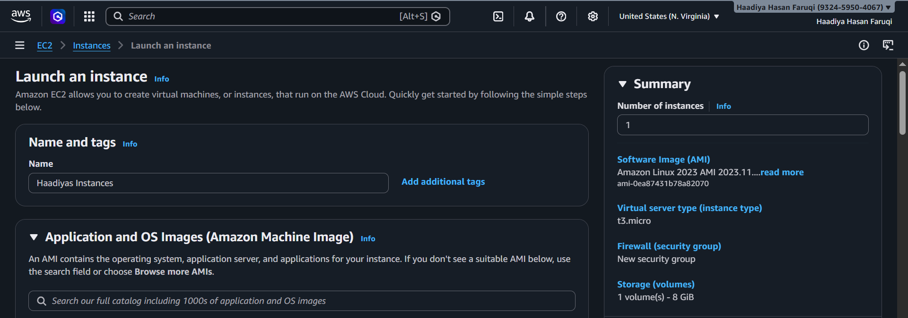
Step 3 : Select Instance Type
Now, choose the instance type, which defines the CPU, memory, and performance capacity of your virtual server.
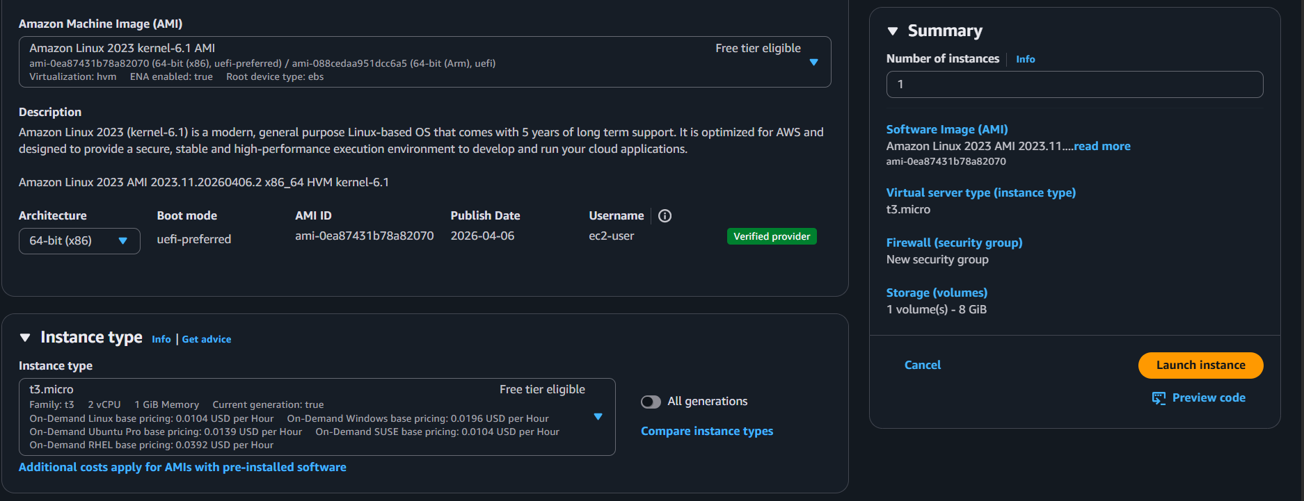

Step 4 : Configure Key Pair and Network Settings
Select or create a key pair for secure login and configure network settings like VPC, subnet, public IP, and security group rules (SSH, HTTP, HTTPS) to control access to the instance.
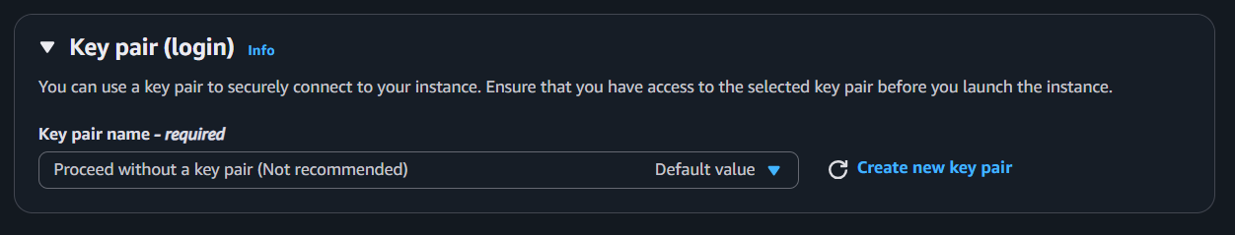
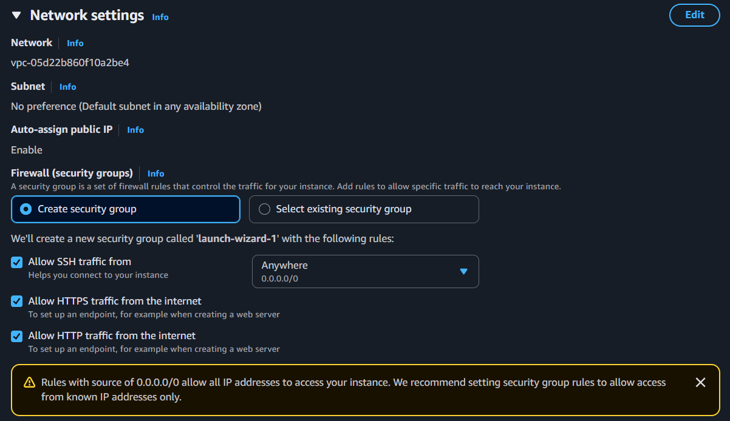
Step 5 : Configure Storage
Set the storage size (e.g., 8 GiB) and volume type (gp3) for your instance, which determines how much data your server can store.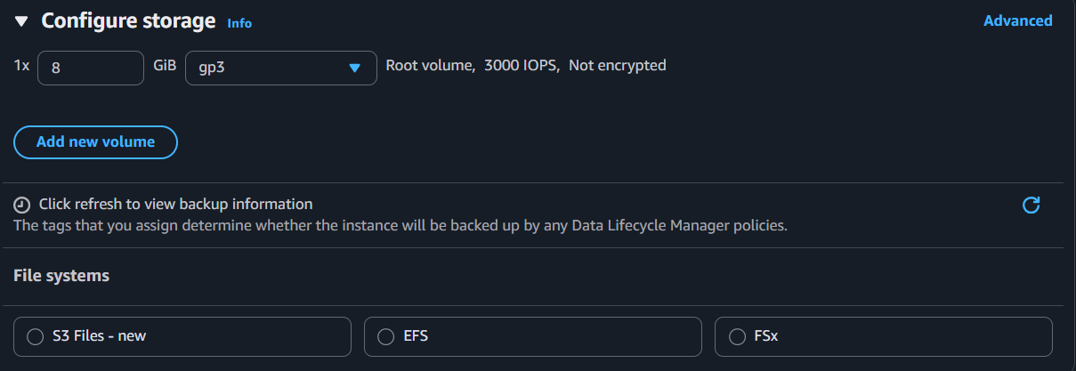
Step 6 : Storage Instance Successfully Created
After clicking “Launch Instance,” the system shows a success message indicating that your EC2 instance has been created and is now being initialized in the cloud.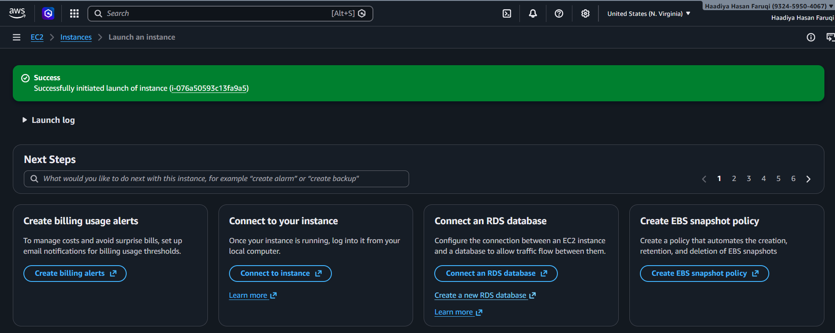
Step 7 : Create an EBS Volume
Set up the EBS volume by selecting volume type (gp3), size (e.g., 8 GiB), IOPS, throughput, and availability zone, which defines the storage performance and location for your instance.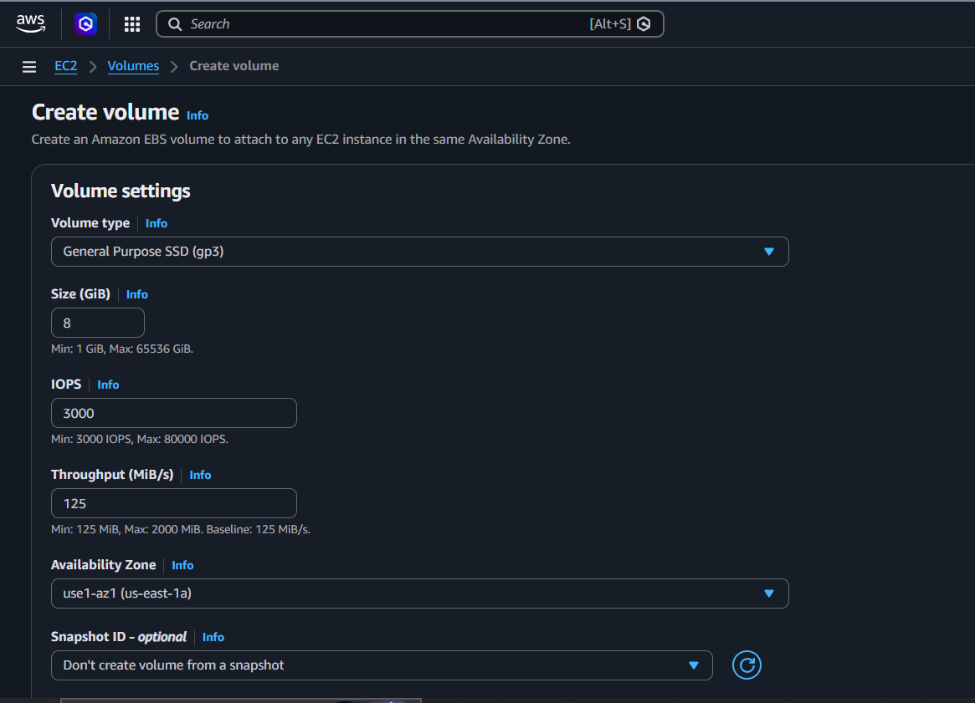
Step 8 : Viewing the Details
Here, select the running instances to view its details and other configuration information.
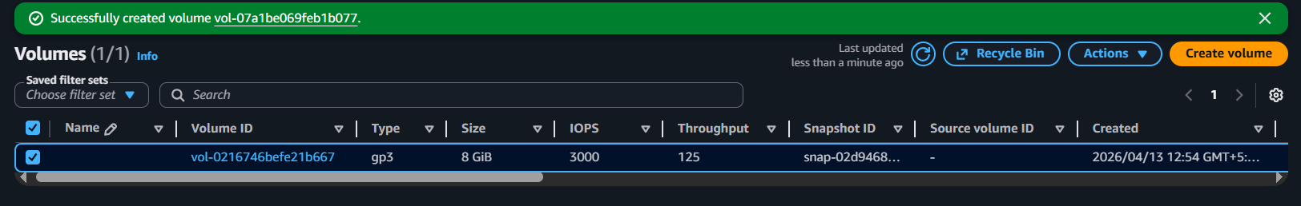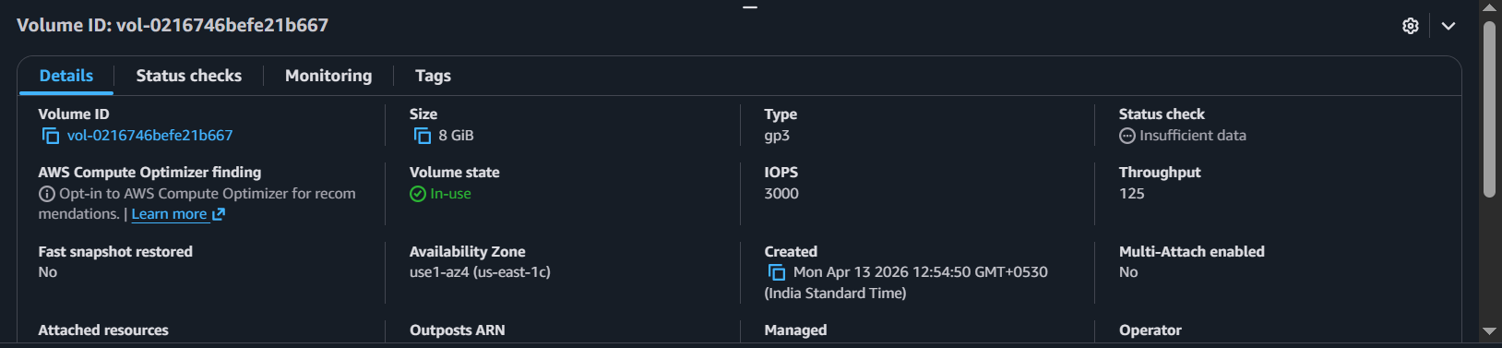
Step 9 : Connect the Instance
Choose the connection method and click “Connect” to access the virtual server directly from the browser itself.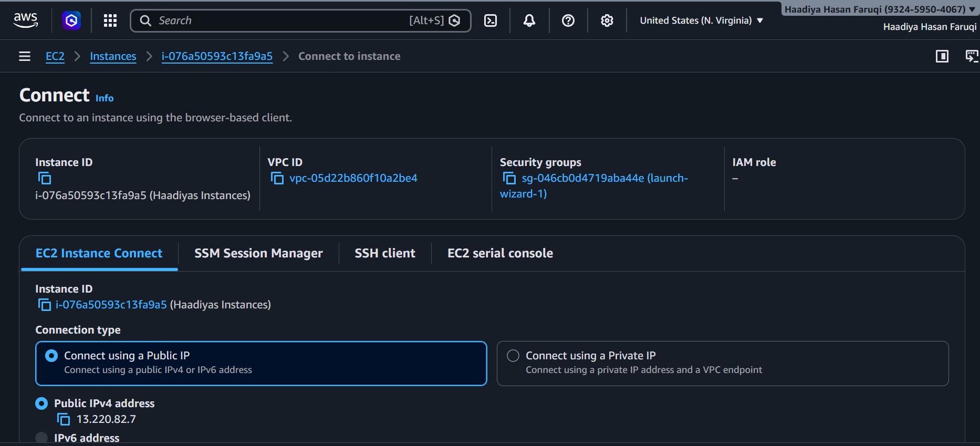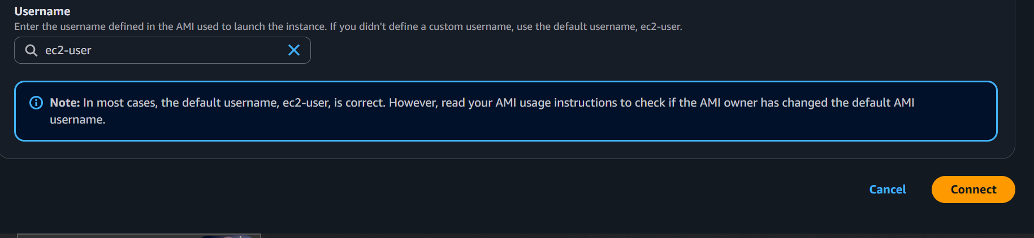

Step 10 : Execute Commands in Instance Terminal
Use the terminal to run Linux commands like creating directories (mkdir), navigating folders (cd), creating files (vim), and displaying content (cat) to interact with the EC2 instance.
